**Robot Aleart Algorithm**   
  
This algorithm for a robot that gives a alerts to a group of people if they do not apply a social spacing of less than two meters  
  
Outline :  
1. Technologies used  
2. Mechanism of using this technologies together  
3. Work phases

Technologies used :We have 3 main types of technologies  
1.1 Input units  
1.2 Processing units  
1.3 Output units

1.1 Input units :  
1.1.1 Camera: responsible for inserting photos and videos.

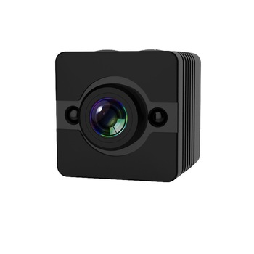

1.1.2 Ibeacon :  
1.Bluetooth : is a wireless technology used to exchange data between fixed and mobile devices over short distances.  
  
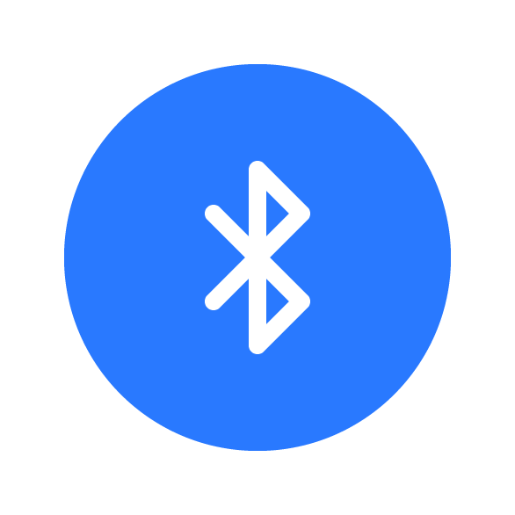

2.ibeacon : Technology from( Apple company) To take advantage of the Bluetooth Low Energy technology found in Bluetooth 4 and the accelerometer, as well as some sensors in the GPS to determine the location.  
  
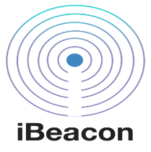  
1.2 Processing units **:**1.2.1 OpenCV : A library for image and video processing that supports languages such as C ++, C, Python, and Java. The OpenCV library is used for all types of image and video processing that include face recognition and discovery, reading of traffic boards, photo editing, optical character recognition.

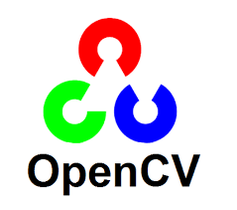  
1.2.2 TenserFlow : It is open source symbolic mathematics library, and machine learning applications such as neural networks are also used in machine learning. It is used in research and productivity by Google.  
  
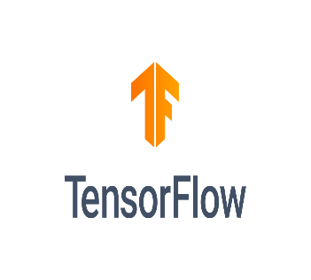

1.2.3 Python : is an interpreter, object-oriented, high-level programming language with dynamic semantics. Its high-level built in data structures, combined with dynamic typing and dynamic binding, make it very attractive for Rapid Application Development, as well as for use as a scripting or glue language to connect existing components together.  
  
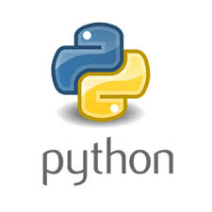

‍  
: 1.3 Output units  
1.3.1 Output Screen : It is the unit responsible for displaying data to the user.  
  


1.3.2 Speaker : is an output hardware device that connects to a computer to generate sound.  
  


Mechanism of using technologies together :

End

Robot Give Alearts to people

Chacking the signal & procress

Robot learing by AI (TenserFlow)

Input process by Control of Panel of Robot (Python program)

Video process by video & calib3d unit (OpenCV) & count MAC addresses

Map location by ibeacon

Video by Camera

Start

NO

Yas

Save Information by storg unit (SQL Database)

No

YAS

Work phases :  
1. Get Information & Signal from Camera & Ibeacon  
2.Video & Location Processing by OpeanCV  
3.1. Process control by Python program & save the variable in SQL Database  
3.2. The robot teaches itself by TenserFlow Library  
4. The robot gives to people alerts